**INFO 5100 - AED - Travel Management System Final Project**

**Travel Management System**

* To manage your favorite trip, avoid using multiple websites or agents' contact. Let's keep everything together. Here, we devise a solution to avoid all that difficulty and make the journey as easy and safe as possible.
* Travel Management System is a java swing application that is an end-to-end complete software solution that allows administrators and users to easily book and track the system while also analyzing the inventory.
* This travel management solution could include all aspects of travel, such as flights, buses, cars, insurance, restaurants, and hotels.

**Approach**

* In this application, the system administrator manages the network, the city, and the businesses that are Travel, Insurance, Lifestyle, Rentals, and organizations.
* Enterprise admin assigns the organizations (Flight, Bus, Travel Insurance, Hotel, Restaurant, Car Rent, and car Booking) admins and organization admins can manage customer data, service providers, manage flights, bus bookings, manage creating, approval, rejection of insurance policies, manages rent or booking a car.
* On the user side, users can book flights, buses, policies, rent a car, book a hotel room, and reserve a table at a restaurant.
* For flight selection, we use components such as external flight APIs. Additionally, when a user signs up, their email is verified and an OTP is sent to that email for verification purposes. This is done by using email verification.

**Areas to Focus**

* It is a User-Friendly Travel Booking System.
* Data management by MySQL.
* Compare the best flight options for your upcoming trip and book a convenient flight ticket.
* Look for the best and most convenient bus and select one.
* Travel facilities are available at the destination. See the beautiful places nearby the destination by renting or booking a car and taking your time.
* Select the best hotel and reserve your room.
* Enjoy the delicious food and explore the food while avoiding the wait by booking a table at a restaurant with us.
* Safety is the most important consideration; choose the best insurance policy and compare its premium, tenure, price, and duration to determine which is best for you.

**Conclusion**

* We believe that managing all travel from one location simplifies data management and can provide a pleasurable experience for users.
* A safer, easier-to-manage and more cost-effective travel experience can be provided.
* The main purpose of the travel management system is to keep track of flight, bus, and car bookings, car rentals, restaurant bookings and manage restaurant orders, and select the best insurance policy.

**Flow Diagram**

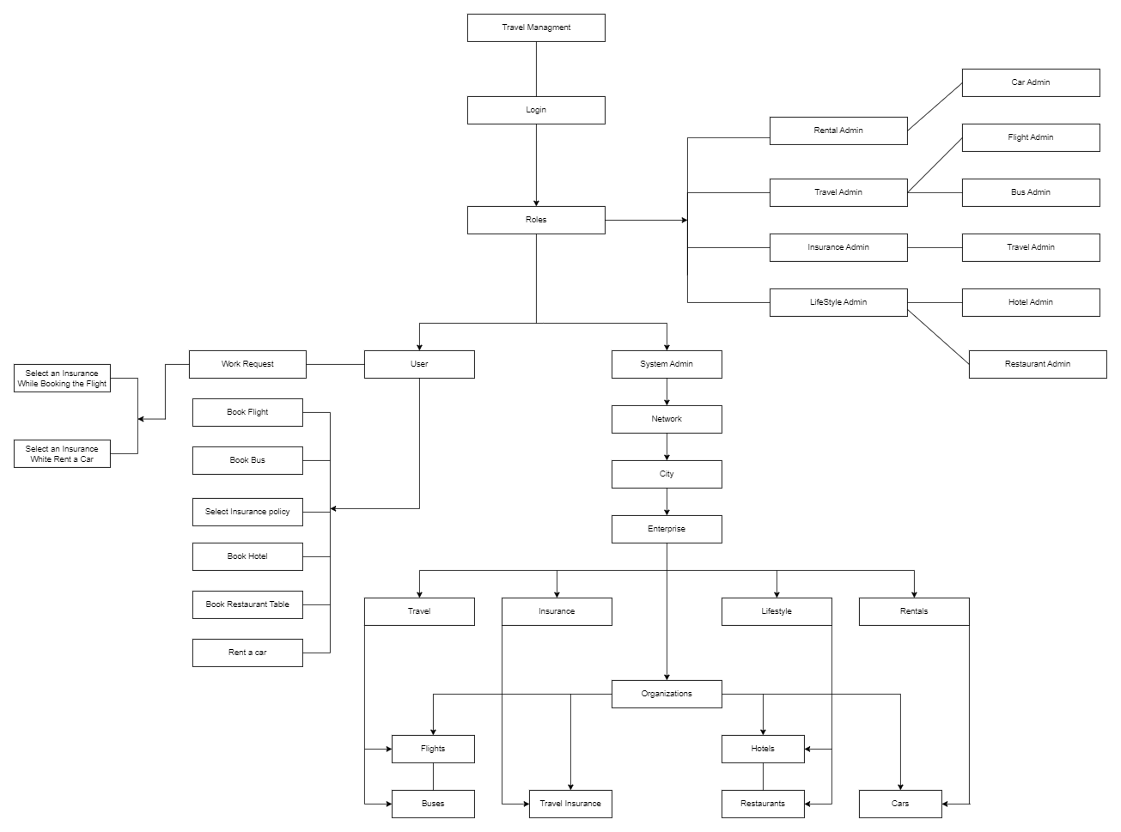

**Class Diagram**

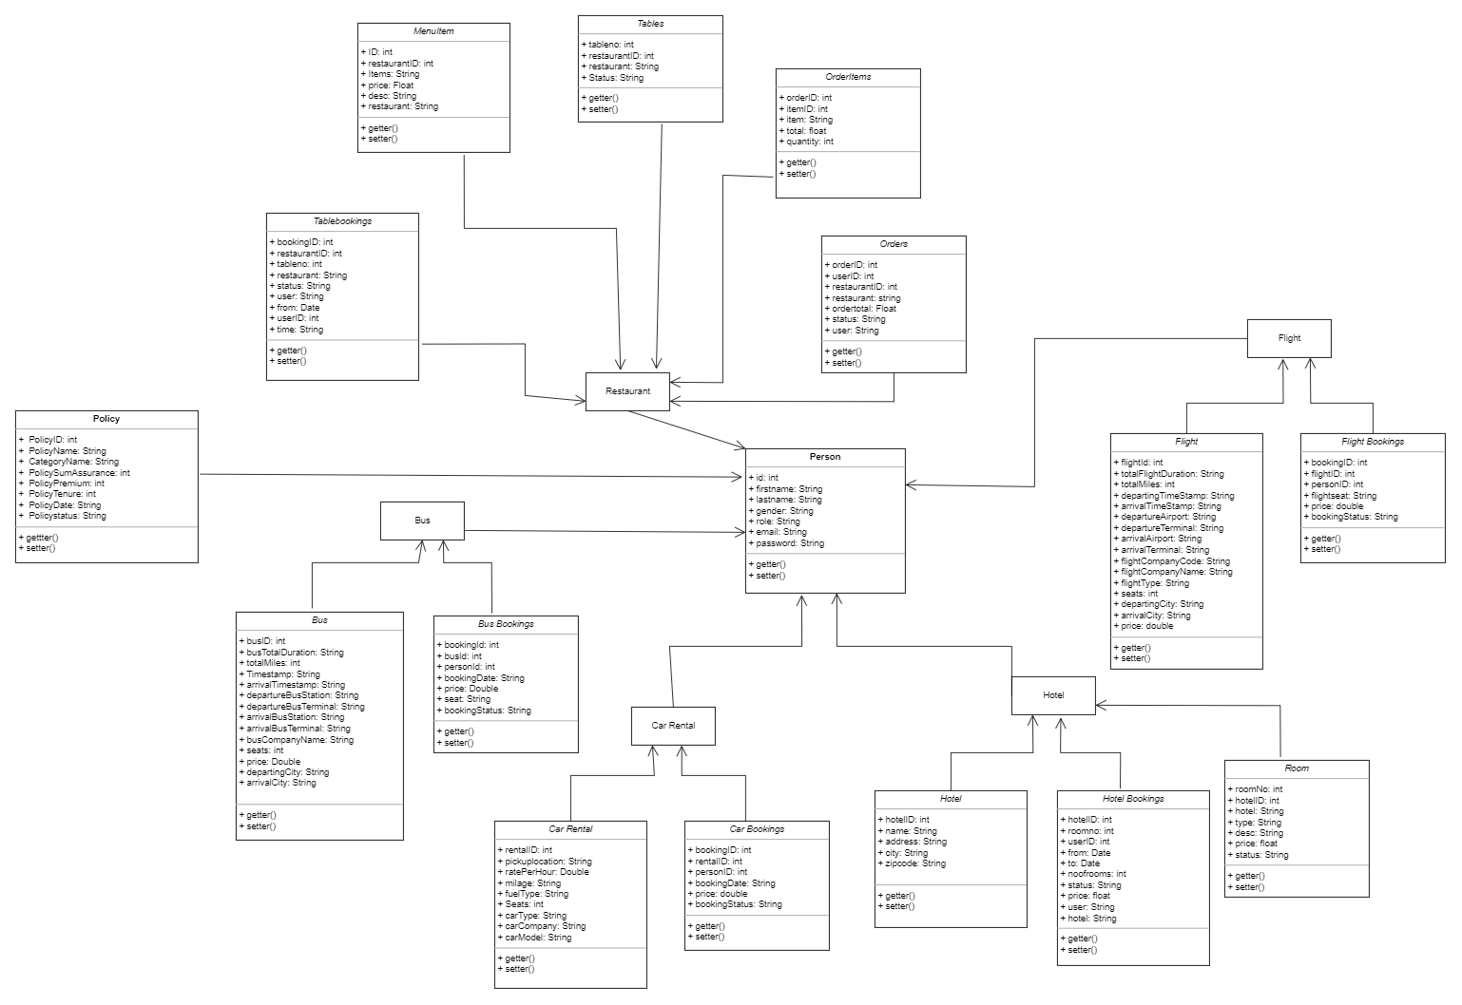

**ER Diagram**

